Source Code:

Project Structure:
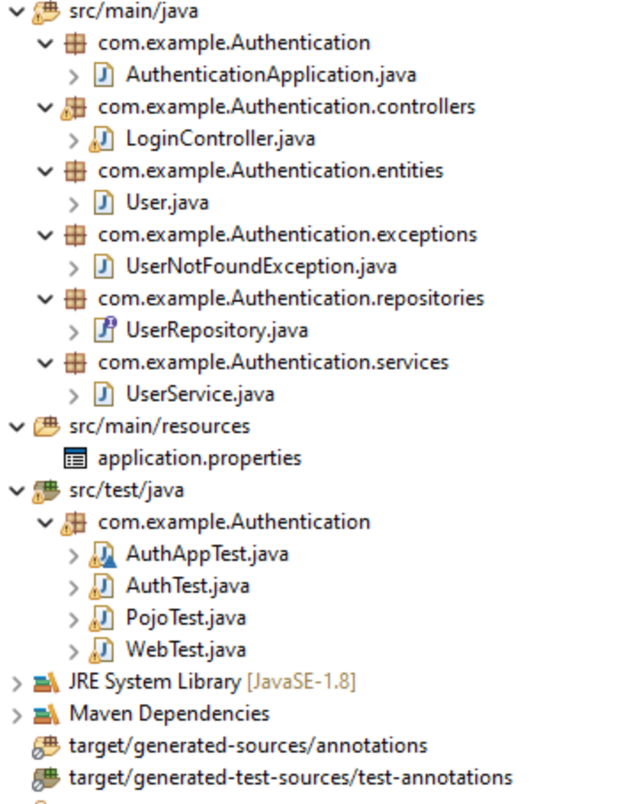

Pom.xml:

<project xmlns="http://maven.apache.org/POM/4.0.0" xmlns:xsi="http://www.w3.org/2001/XMLSchema-instance" xsi:schemaLocation="http://maven.apache.org/POM/4.0.0 https://maven.apache.org/xsd/maven-4.0.0.xsd">
<modelVersion>4.0.0</modelVersion>
<parent>
<groupId>org.springframework.boot</groupId>
<artifactId>spring-boot-starter-parent</artifactId>
<version>2.4.3</version>
<relativePath/>
<!-- lookup parent from repository -->
</parent>
<groupId>com.example</groupId>
<artifactId>Authentication</artifactId>
<version>0.0.1-SNAPSHOT</version>
<name>Authentication</name>
<description>Test</description>
<properties>
<java.version>1.8</java.version>
</properties>
<dependencies>

<dependency>
<groupId>org.springframework.boot</groupId>
<artifactId>spring-boot-starter-data-jpa</artifactId>
</dependency>
<dependency>
<groupId>org.springframework.boot</groupId>
<artifactId>spring-boot-starter-web</artifactId>
</dependency>
<dependency>
<groupId>com.h2database</groupId>
<artifactId>h2</artifactId>
<scope>runtime</scope>
</dependency>
<dependency>
<groupId>mysql</groupId>
<artifactId>mysql-connector-java</artifactId>
<scope>runtime</scope>
</dependency>
<dependency>
<groupId>org.projectlombok</groupId>
<artifactId>lombok</artifactId>
<optional>true</optional>
</dependency>
<dependency>
<groupId>org.springframework.boot</groupId>
<artifactId>spring-boot-starter-test</artifactId>
<scope>test</scope>
</dependency>
</dependencies>
<build>
<plugins>
<plugin>
<groupId>org.springframework.boot</groupId>
<artifactId>spring-boot-maven-plugin</artifactId>
<configuration>
<excludes>
<exclude>
<groupId>org.projectlombok</groupId>
<artifactId>lombok</artifactId>
</exclude>
</excludes>
</configuration>
</plugin>
</plugins>
</build>
</project>

Application.properties:

spring.jpa.hibernate.ddl-auto=update
spring.datasource.url=jdbc:mysql://${MYSQL_HOST:localhost}:3306/Auth
spring.datasource.username=root
spring.datasource.password=Spidey@0987
logging.level.org.springframework.web: DEBUG
server.port=8090
server.error.whitelabel.enabled=false

AuthenticationApplication.java

package com.example.Authentication;
import org.springframework.boot.SpringApplication;
import org.springframework.boot.autoconfigure.SpringBootApplication;
@SpringBootApplication
public class AuthenticationApplication {
public static void main(String[] args) {
SpringApplication.run(AuthenticationApplication.class, args);
}
}

LoginController:
package com.example.Authentication.controllers;
import org.slf4j.Logger;
import org.slf4j.LoggerFactory;
import org.springframework.beans.factory.annotation.Autowired;
import org.springframework.stereotype.Controller;
import org.springframework.ui.ModelMap;
import org.springframework.web.bind.annotation.GetMapping;
import org.springframework.web.bind.annotation.PostMapping;
import org.springframework.web.bind.annotation.RequestParam;
import org.springframework.web.bind.annotation.ResponseBody;
import org.springframework.web.bind.annotation.RestController;
import com.example.Authentication.entities.User;
import com.example.Authentication.repositories.UserRepository;

@RestController
public class LoginController {
@Autowired
UserRepository userRepository;
@GetMapping(value="/")
public String showIndexPage(ModelMap model){
return "<!DOCTYPE html>\n"
+ "<html>\n"
+ "<head>\n"
+ " <style>\n"
+ " .center {\n"
+ " display: flex;\n"
+ " justify-content: center;\n"
+ " align-items: center;\n"
+ " height: 100vh;\n"
+ " }\n"
+ " \n"
+ " .container {\n"
+ " background-color:#FFEFD5;\n"
+ " border-radius: 5px;\n"
+ " box-shadow: 0 2px 4px rgba(0, 0, 0, 0.1);\n"
+ " padding: 20px;\n"
+ " max-width: 400px;\n"
+ " width: 100%;\n"
+ " }\n"
+ " \n"
+ " h1 {\n"
+ " text-align: center;\n"
+ " margin-top: 0;\n"
+ " }\n"
+ " \n"
+ " form {\n"
+ " margin-top: 20px;\n"
+ " }\n"
+ " \n"
+ " input[type=\"text\"],\n"
+ " input[type=\"password\"] {\n"
+ " width: 100%;\n"
+ " padding: 10px;\n"
+ " margin-bottom: 10px;\n"
+ " border: 1px solid #ccc;\n"
+ " border-radius: 4px;\n"
+ " box-sizing: border-box;\n"
+ " }\n"
+ " \n"
+ " input[type=\"submit\"] {\n"
+ " width: 100%;\n"
+ " padding: 10px;\n"
+ " border: none;\n"
+ " border-radius: 4px;\n"
+ " background-color: #4CAF50;\n"
+ " color: #fff;\n"
+ " cursor: pointer;\n"
+ " }\n"
+ " </style>\n"
+ "</head>\n"
+ "<body>\n"
+ " <div class=\"center\">\n"
+ " <div class=\"container\">\n"
+ " <h1>User Login Page</h1>\n"
+ " <form method=\"get\" action=\"register\">\n"
+ " <h3>Enter User Details:</h3>\n"
+ " <input type=\"text\" id=\"name\" name=\"name\" placeholder=\"Name\" required>\n"
+ " <input type=\"text\" id=\"email\" name=\"email\" placeholder=\"Email\" required>\n"
+ " <input type=\"password\" id=\"password\" name=\"password\" placeholder=\"Password\" required>\n"
+ " <input type=\"submit\" value=\"Enter\" />\n"
+ " </form>\n"
+ " </div>\n"
+ " </div>\n"
+ "</body>\n"
+ "</html>\n"
+ "";
}
@GetMapping("/register")
public String showLogin(@RequestParam("name") String name, @RequestParam("email") String email, @RequestParam("password") String password, ModelMap map) {
User u = new User(name,email,password);
userRepository.save(u);

return "<!DOCTYPE html>\n"
+ "<html>\n"
+ "<head>\n"
+ " <style>\n"
+ " body {\n"
+ " background-color: #FFEFD5;\n"
+ " margin: 0;\n"
+ " padding: 0;\n"
+ " font-family: Arial, sans-serif;\n"
+ " }\n"
+ "\n"
+ " .center {\n"
+ " display: flex;\n"
+ " justify-content: center;\n"
+ " align-items: center;\n"
+ " height: 100vh;\n"
+ " }\n"
+ "\n"
+ " .hello-title {\n"
+ " font-size: 32px;\n"
+ " color: #FF4500;\n"
+ " margin-top: 0;\n"
+ " }\n"
+ " </style>\n"
+ "</head>\n"
+ "<body>\n"
+ " <div class=\"center\">\n"
+ " <h2 class=\"hello-title\">Logged In!</h2>\n"
+ " </div>\n"
+ "</body>\n"
+ "</html>\n"
+ "";
}

@PostMapping("/login")
public String submitLogin(@RequestParam String username, @RequestParam String password){
return "Success";

}
}

user.java:
package com.example.Authentication.entities;

import javax.persistence.Entity;
import javax.persistence.GeneratedValue;
import javax.persistence.GenerationType;
import javax.persistence.Id;

@Entity // This tells Hibernate to make a table out of this class
public class User {
@Id
@GeneratedValue(strategy=GenerationType.IDENTITY)
private Integer id;

private String name;

private String email;

private String password;

public User()
{

}

public User(String name, String email, String password) {
this.name = name;
this.email = email;
this.password = password;
}

public String getPassword() {
return password;
}

public void setPassword(String password) {
this.password = password;
}

public Integer getId() {
return id;
}

public void setId(Integer id) {
this.id = id;
}

public String getName() {
return name;
}

public void setName(String name) {
this.name = name;
}

public String getEmail() {
return email;
}

public void setEmail(String email) {
this.email = email;
}

@Override
public String toString() {

return "<br><h3>" + name + " [" + id + "]:" + "</h3><h4>email: " + email + "</h4><h4>password: " + password + "</h4><br>";
}

}

UserNotFoundException:

package com.example.Authentication.exceptions;

public class UserNotFoundException extends RuntimeException {
private static final long serialVersionUID = 1L;
}

User Repo Interface:

package com.example.Authentication.repositories;

import org.springframework.data.repository.CrudRepository;

import com.example.Authentication.entities.User;

public interface UserRepository extends CrudRepository<User, Integer> {

public User findByName(String name);
}

User Service:

package com.example.Authentication.services;

import java.util.Optional;

import org.springframework.beans.factory.annotation.Autowired;
import org.springframework.stereotype.Service;

import com.example.Authentication.entities.User;
import com.example.Authentication.exceptions.UserNotFoundException;
import com.example.Authentication.repositories.UserRepository;

@Service
public class UserService {

@Autowired
private UserRepository userRepository;

public Iterable<User> GetAllUsers()
{
return userRepository.findAll();
}

public User GetUserByName(String name) {
User foundUser = userRepository.findByName(name);
return foundUser;
}

public User GetUserById(int id) {
Optional<User> foundUser = userRepository.findById(id);

//TODO: we need to decide how to handle a "Not Found" condition

if (!foundUser.isPresent()) {
throw new UserNotFoundException();
}
return(foundUser.get());
}
public void UpdateUser(User usertoUpdate) {
userRepository.save(usertoUpdate);
}

}

J Unit Tests classes:

Auth App test:
package com.example.Authentication;

import static org.junit.jupiter.api.Assertions.assertEquals;
import static org.junit.jupiter.api.Assertions.assertNotEquals;
import static org.junit.jupiter.api.Assertions.assertNotNull;

import org.junit.jupiter.api.Test;
import org.springframework.beans.factory.annotation.Autowired;
import org.springframework.boot.test.context.SpringBootTest;

import com.example.Authentication.entities.User;
import com.example.Authentication.services.UserService;

@SpringBootTest
class AuthAppTest {

@Autowired
private UserService userService;

@Test
void contextLoads() {
}

@Test
void testServiceCall() {
Iterable<User> users = userService.GetAllUsers();
Integer count = 0;

for(User u: users)
count++;

assertNotEquals(count, 0);
}

@Test
void checkAllUsers() {
Iterable<User> users = userService.GetAllUsers();

for(User u: users)
assertNotNull(u);
}
}

Auth test:

package com.example.Authentication;

import com.example.Authentication.entities.User;
import com.example.Authentication.repositories.UserRepository;
import com.example.Authentication.services.UserService;
import org.junit.jupiter.api.Test;
import org.springframework.beans.factory.annotation.Autowired;
import org.springframework.boot.test.autoconfigure.orm.jpa.DataJpaTest;
import org.springframework.boot.test.autoconfigure.orm.jpa.TestEntityManager;
import org.springframework.boot.test.context.SpringBootTest;
import org.junit.jupiter.api.Assertions.*;
import static org.junit.jupiter.api.Assertions.assertEquals;
import static org.junit.jupiter.api.Assertions.assertNotNull;

@DataJpaTest

public class AuthTest {

@Autowired
private TestEntityManager entityManager;

@Autowired
private UserRepository userRepository;

@Test
public void retUserFromName() {
User testUser = new User();
testUser.setName("newTest");
testUser.setEmail("test@email.com");
testUser.setPassword("testpw");
entityManager.persist(testUser);
entityManager.flush();

User found = userRepository.findByName(testUser.getName());

assertEquals(found.getName(), testUser.getName());
}

@Test
public void passNotNull() {

Iterable<User> users = userRepository.findAll();
for(User u: users)
assertNotNull(u.getPassword());
}

@Test
public void NameNotNull() {

Iterable<User> users = userRepository.findAll();
for(User u: users)
assertNotNull(u.getName());
}
@Test
public void EmailNotNull() {
Iterable<User> users = userRepository.findAll();
for(User u: users)
assertNotNull(u.getEmail());
}
}

Pojo test:
package com.example.Authentication;
import com.example.Authentication.entities.User;
import com.example.Authentication.repositories.UserRepository;
import com.example.Authentication.services.UserService;
import org.junit.jupiter.api.Test;
import org.junit.jupiter.api.Assertions.*;
import static org.junit.jupiter.api.Assertions.assertEquals;
import static org.junit.jupiter.api.Assertions.assertNotNull;
public class PojoTest {
@Test
public void getAndSetPassword() {
User testUser = new User();

testUser.setPassword("aryan123");
assertEquals(testUser.getPassword(),"aryan123");
}

@Test
public void getAndSetName() {
User testUser = new User();

testUser.setName("Aryan Garg");
assertEquals(testUser.getName(),"Aryan Garg");
}

@Test
public void getAndSetEmail() {
User testUser = new User();

testUser.setEmail("aryan54@gmail.com");
assertEquals(testUser.getEmail(),"aryan54@gmail.com");
}

@Test
public void checkToString() {
User testUser = new User();

assertNotNull(testUser.toString());
}

@Test
public void checkConstructor() {
User testUser = new User("Aryan Garg","aryan54@gmail.com","aryan123");

User checkUser = new User();
checkUser.setName("Aryan Garg");
checkUser.setEmail("aryan54@gmail.com");
checkUser.setPassword("aryan123");

assertEquals(testUser.getName(), checkUser.getName());
assertEquals(testUser.getEmail(), checkUser.getEmail());
assertEquals(testUser.getPassword(), checkUser.getPassword());
}

@Test
public void testDefaultConstructor() {
User testUser = new User();

assertNotNull(testUser);
}
}

Web test

package com.example.Authentication;

import com.example.Authentication.controllers.LoginController;
import org.junit.jupiter.api.Test;
import org.springframework.beans.factory.annotation.Autowired;
import org.springframework.boot.test.context.SpringBootTest;
import org.springframework.boot.web.server.LocalServerPort;
import org.springframework.test.web.servlet.MockMvc;
import org.springframework.boot.test.autoconfigure.web.servlet.AutoConfigureMockMvc;
import static org.junit.jupiter.api.Assertions.assertEquals;
import static org.hamcrest.Matchers.containsString;
import static org.springframework.test.web.servlet.request.MockMvcRequestBuilders.get;
import static org.springframework.test.web.servlet.result.MockMvcResultHandlers.print;
import static org.springframework.test.web.servlet.result.MockMvcResultMatchers.content;
import static org.springframework.test.web.servlet.result.MockMvcResultMatchers.status;

@SpringBootTest(webEnvironment = SpringBootTest.WebEnvironment.RANDOM_PORT)
@AutoConfigureMockMvc
public class WebTest {

@LocalServerPort
private int port;

@Autowired
private LoginController controller;

@Autowired
private MockMvc mockMvc;

@Test
public void shouldReturnDefaultMessage() throws Exception {
this.mockMvc.perform(get("/")).andDo(print()).andExpect(status().isOk());
}

@Test
public void checkLoginPage() throws Exception {
this.mockMvc.perform(get("/login")).andDo(print()).andExpect(status().is4xxClientError());
}

@Test
public void checkUsersPage() throws Exception {
this.mockMvc.perform(get("/allusers")).andDo(print()).andExpect(status().isOk());
}
}

